**VOWELS**

height:

low = 0

mid = 1

high = 2

frontness relative to distance from back of mouth = 0:

frontness of different vowels:

*front:*

* for front high, frontness = 4
* for front mid, frontness = 3
* for front low, frontness = 2

*central*:

* for central, frontness = 1

*back:*

for back, frontness = 0

tense = 1, lax = 0

for diphthongs: take height and frontness of first vowel, but make it [+tense], to account for the articulatory upwards motion.

Diphthongs also get an extra value:

If no diphthong, = 3

If second part of diphthong is front [ɪ], diphthong = 0

If second part of diphthong is back [ʊ], diphthong = 6

We penalize vowel differences x2 as much since they are perceptually salient.

**CONSONANTS**

Manner of articulation: distance of 3

Place of articulation: distance of 2

Voicing: distance of 1

Retroflex (+/-): distance of 1

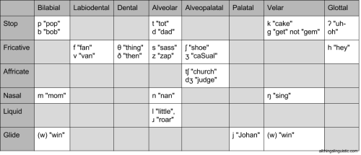

Manner

stop 0

fricative 3

affricate 6

nasal 9

liquid 12

glide 15

Place

Bilabial 0

Labiodental 2

Dental 4

Alveolar 6

Alveopalatal 8

Palatal 10

Velar 12

glottal 14

Voice/Voiceless

Voiced 0

Voiced 1

Approximants

default value 0

lateral 0

retroflex 1

Note: split ARPABET “ER” into AH + R

**STRESS**

Every vowel with a stress difference = penalty 1